Terraform -01

Install Terraform on local PC.

#Steps To Install Terraform on Windows 10 or 8 or 7
1) Download Terraform
https://www.terraform.io/downloads.html
2) Unzip the terraform package
Extract the downloaded zip file, after extracting the zip file you can see terraform.exe file.
Extracted path can be Example "C:\Users\devops\Downloads\terraform_0.12.23_windows_amd64"
3) Configure environment variables for terraform
This PC(MyComputer)—>properties —>advanced system settings–>environment variables—>system variables—>path–edit–>new
paste the path "C:\Users\devops\Downloads\terraform_0.12.23_windows_amd64"
Click on Ok.
4) Verify terraform version
Open gitbash and enter
> terraform version
Terraform v0.12.23
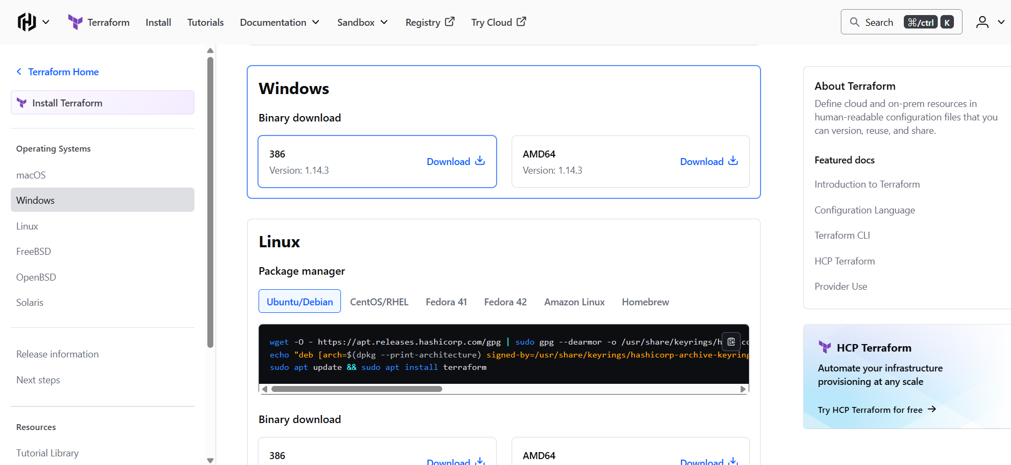

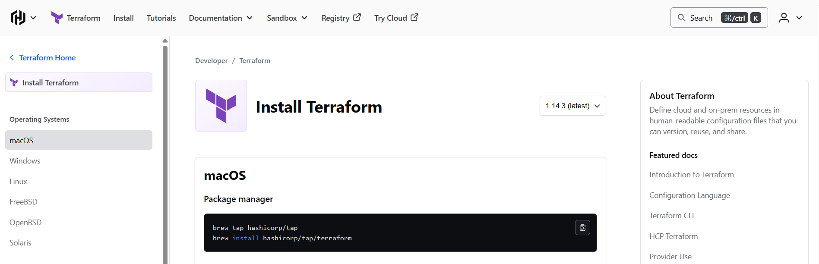

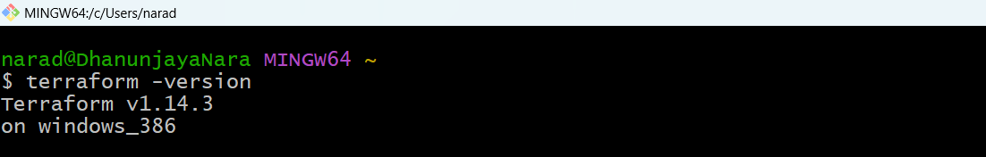

Terraform code (HCL – HashiCorp Configuration Language)
👉 File name: main.tf

resource "local_file" "my_pet" {
• resource → Terraform keyword (means “create something”)
• local_file → Resource type (create a file on local machine)
• my_pet → Resource name (your own reference name)

filename = "pets.txt"
This tells Terraform:
Create a file named pets.txt

content = "I love pets!"
This is the content inside the file
Whatever string you write here will be written to pets.txt

}
End of resource block

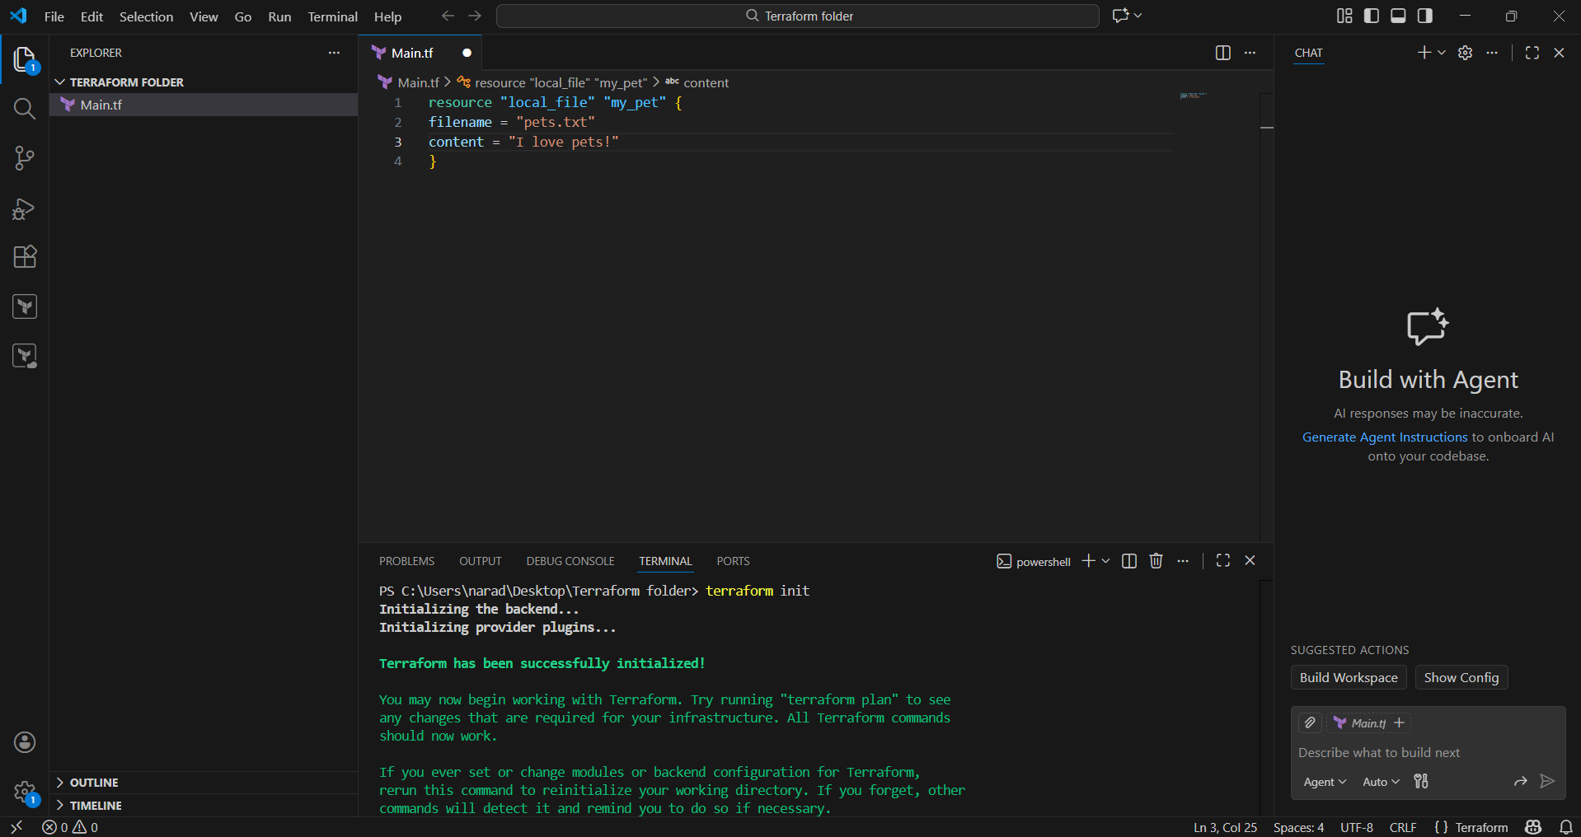

terraform innit -Initialise
Why exactly do we need it?
Terraform cannot work without initialization.

What it does:
- Downloads required providers (AWS, Azure, local, random, etc.)
- Sets up backend (where state file lives)
- Prepares .terraform/ directory

Example:
Your code uses:
resource "local_file" "my_pet"
Terraform says:
“I need the local provider. Let me download it.”
That happens in init.

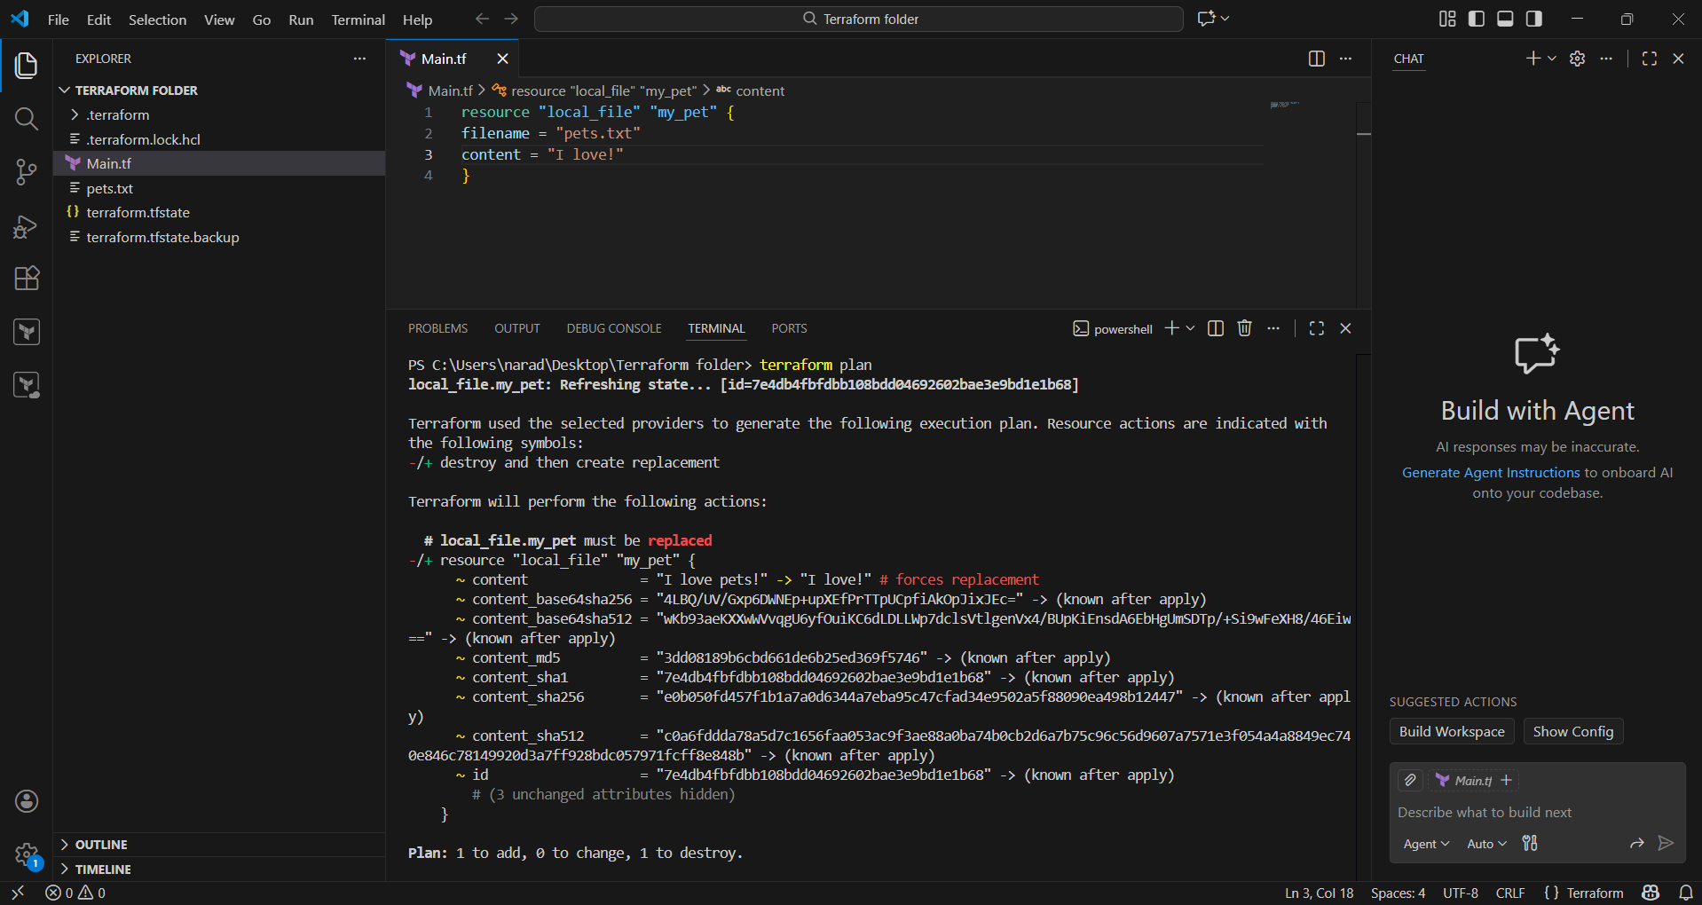
terraform plan
Why exactly do we need it?
To see what Terraform will do before doing it.

What it does:
- Reads .tf files
- Compares:
  - Desired state (your code)
  - Current state (terraform.tfstate)
- Shows execution plan

Example output:
+ create pets.txt
Means:
Terraform WILL create a file, but hasn’t yet.

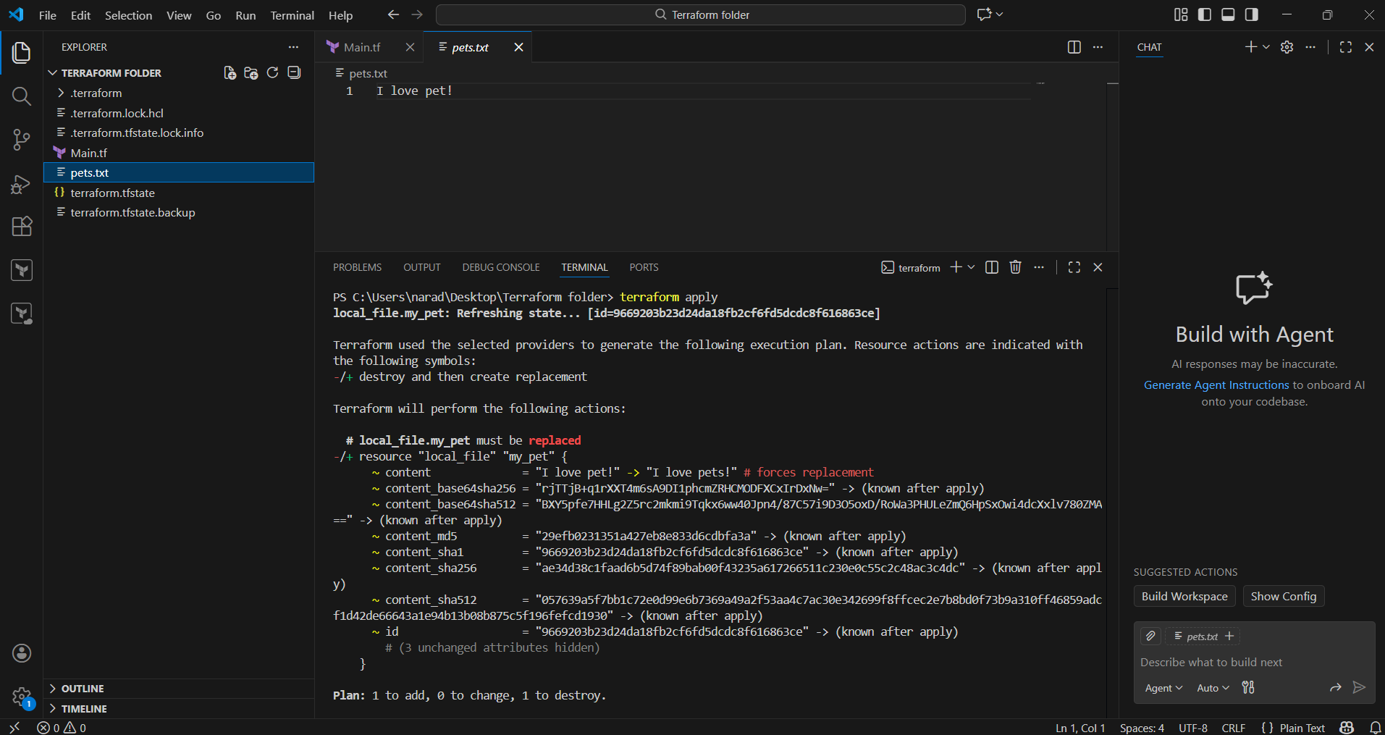

terraform apply
Why exactly do we need it?
This is the command that actually creates or modifies resources.

What it does:
- Executes the plan
- Creates / updates / deletes resources
- Updates terraform.tfstate

Example:
terraform apply
Result:
- pets.txt is created
- Content written
- State file updated

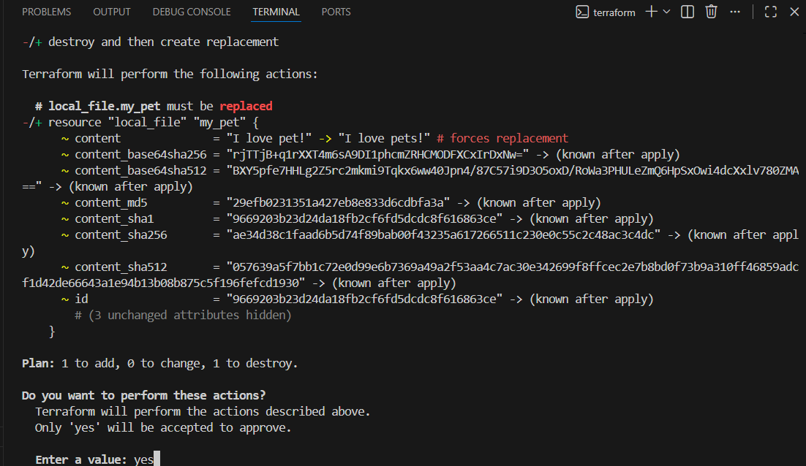
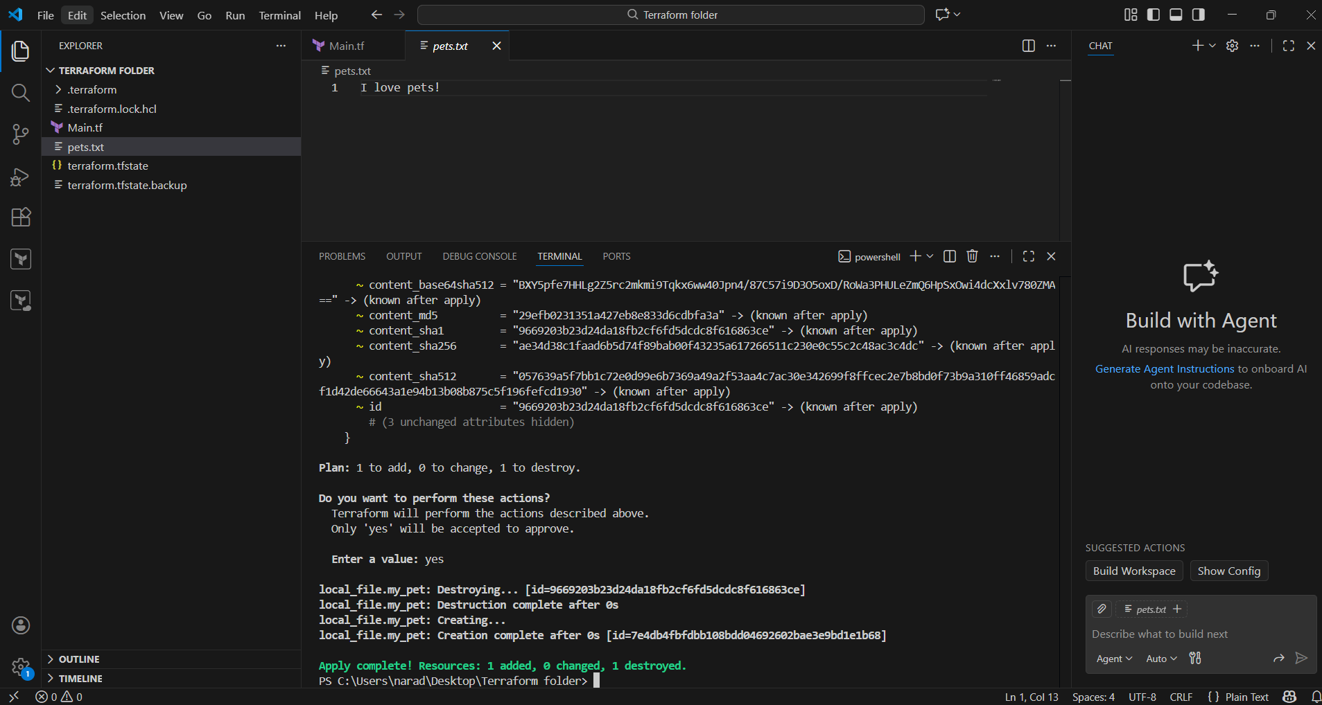

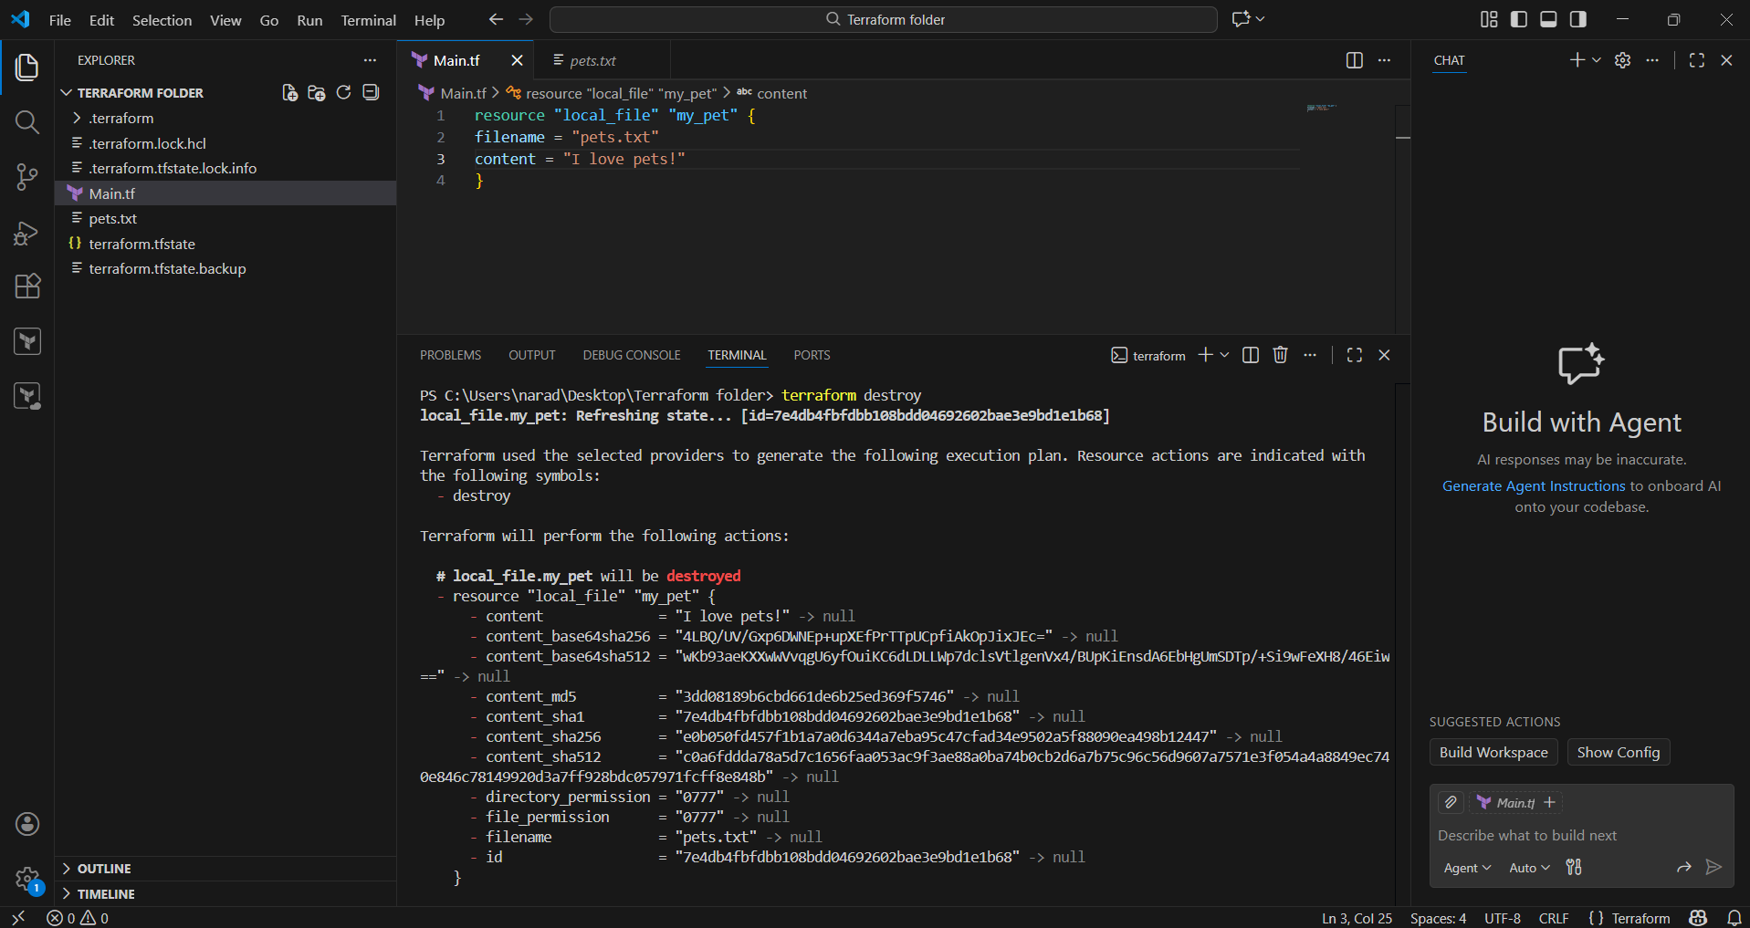

terraform destroy

Why exactly do we need it?
To clean up infrastructure and avoid cost.

What it does:
- Reads state file
- Deletes all resources created by Terraform

Example:
terraform destroy
Result:
- pets.txt deleted
- AWS EC2 deleted
- Load balancer deleted

Random Provider
Used here:
resource "random_pet" "my-pet" {
prefix = "MR"
separator = "."
length = "1"
}

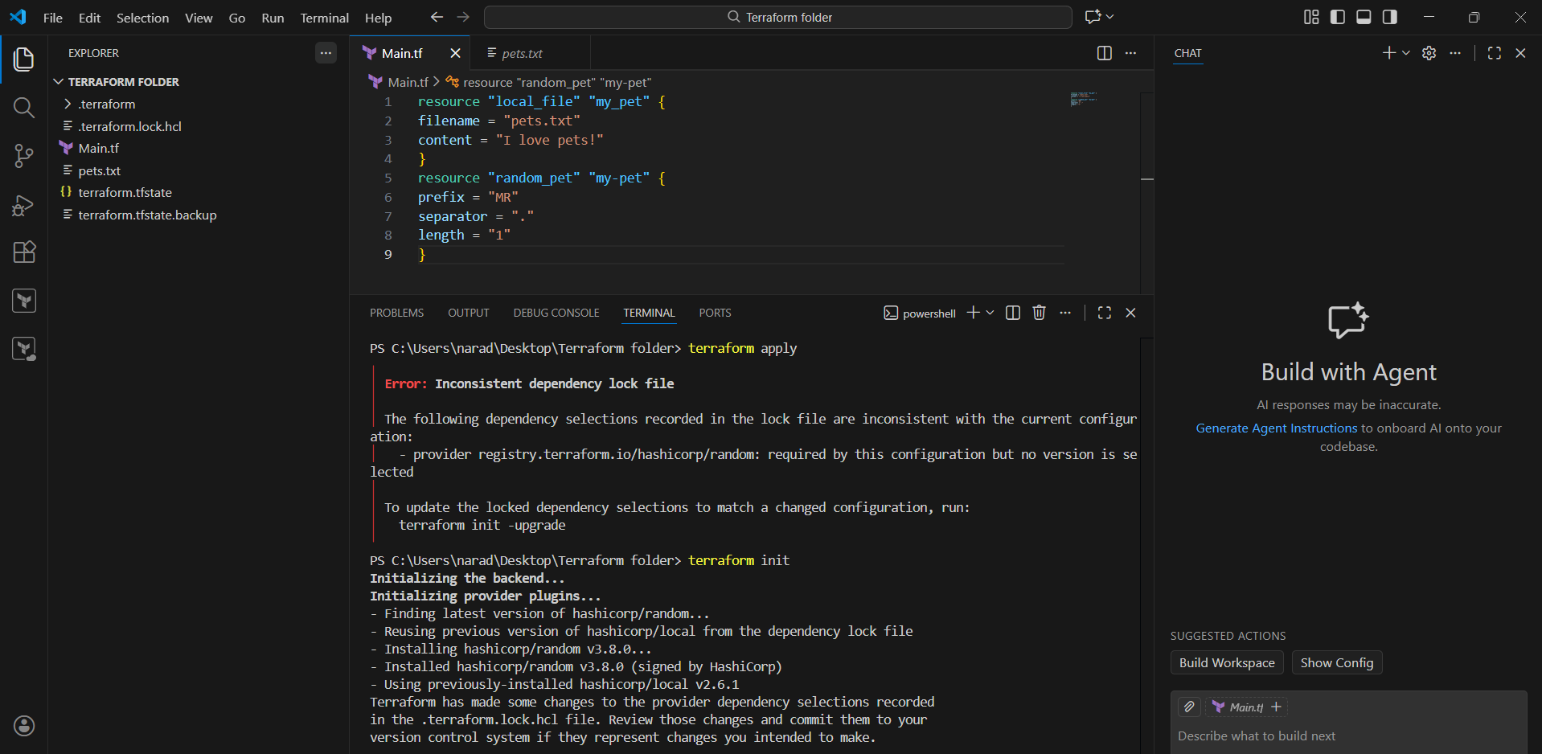
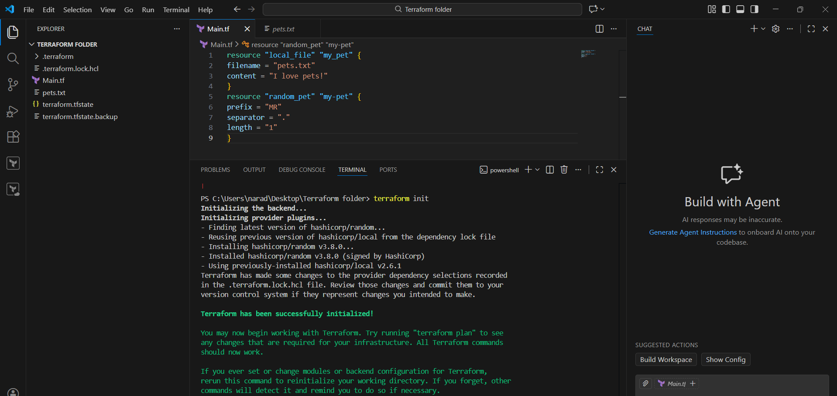
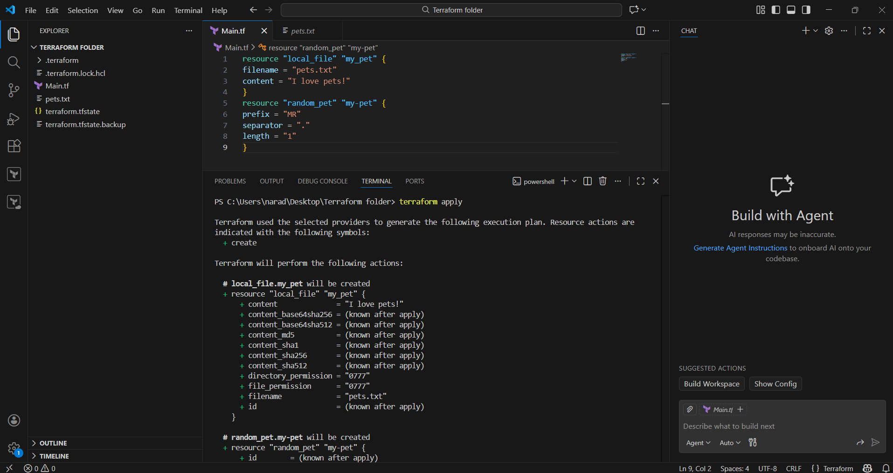

Integrate a sample terraform template in Jenkins

TITLE:
Integrating terraform template in Jenkins

PREREQUISITES:
Code to pushed to github from terraform folder
Ec2 instance with Jenkins running in it
Pipeline and git plugins in Jenkins

STEP-BY-STEP-IMPLIMENTATION:

Run:
vi .gitignore
Press i (insert mode) and paste this:
*.tfstate
*.tfstate.backup
pets.txt
.terraform/
Press:
ESC
:wq

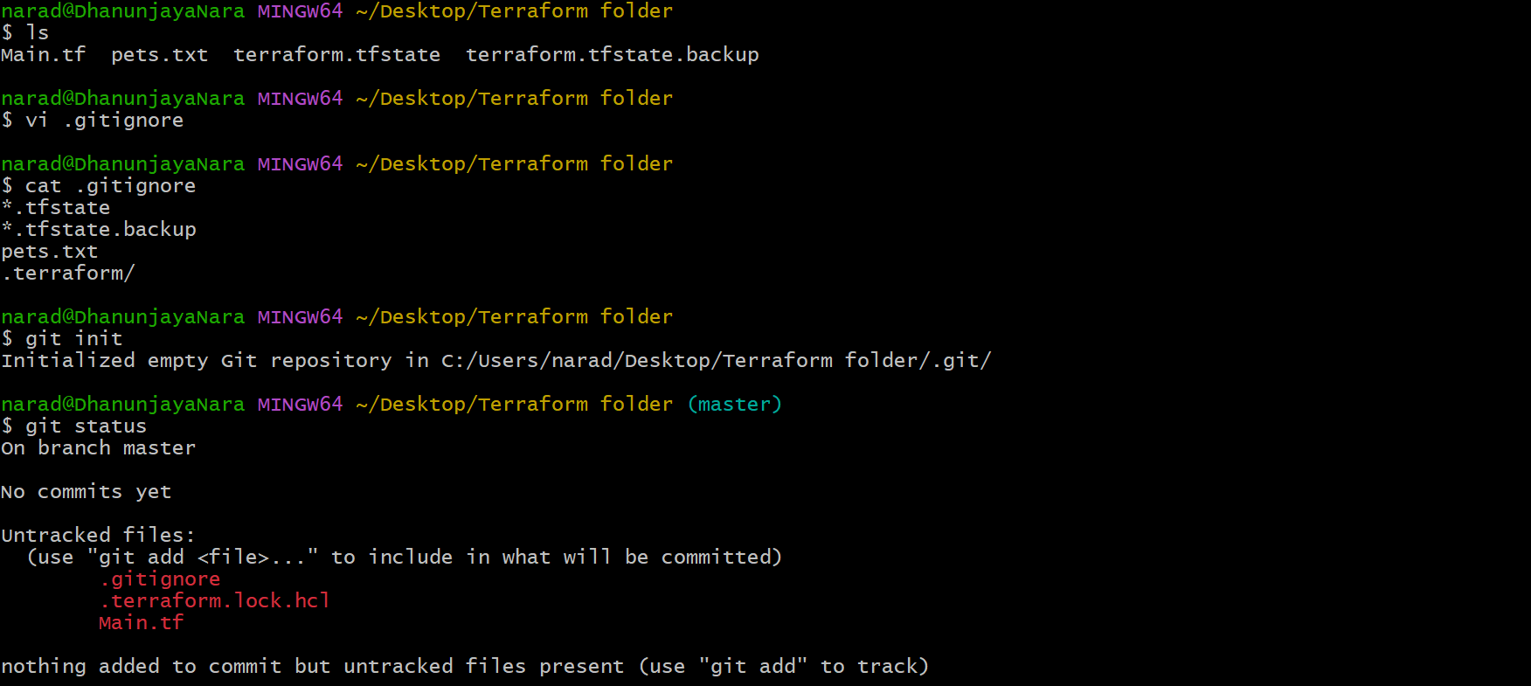

Push them to GitHUb
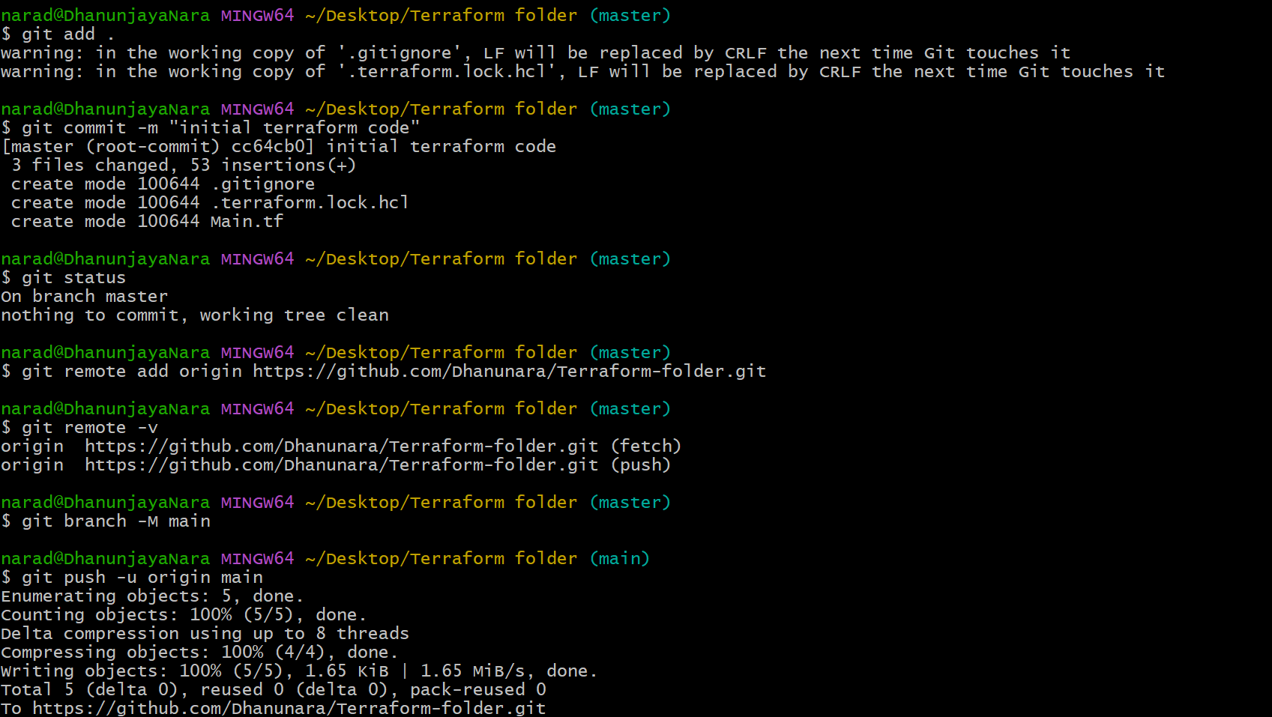
Install Terraform and git in the Jenkins server
Create a file (Jenkins file) and paste the pipeline inside it
Now push that pipeline to GitHub
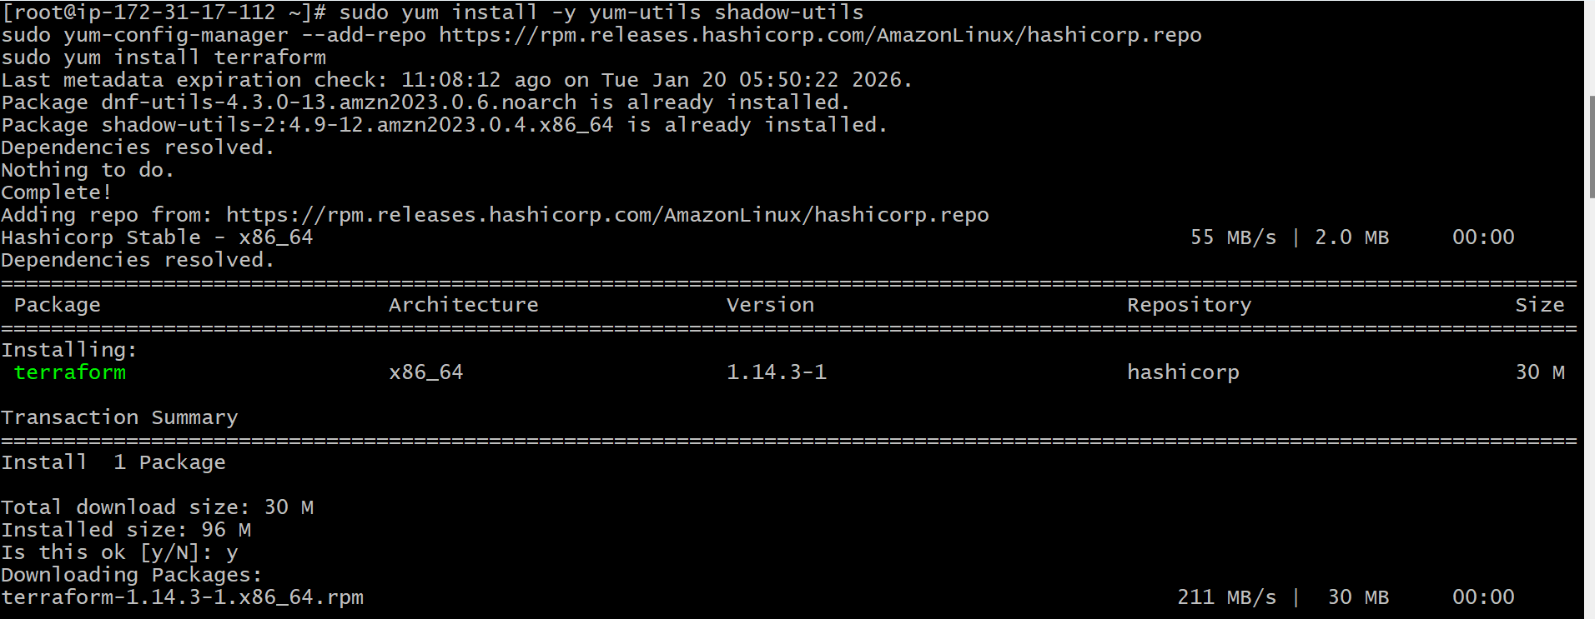
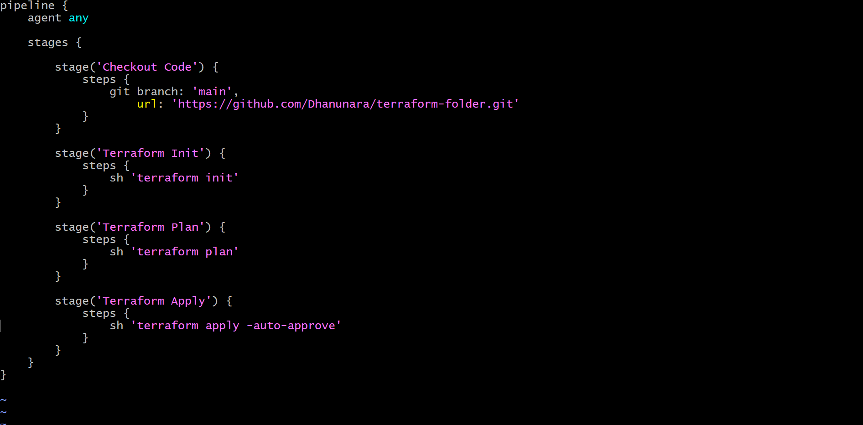
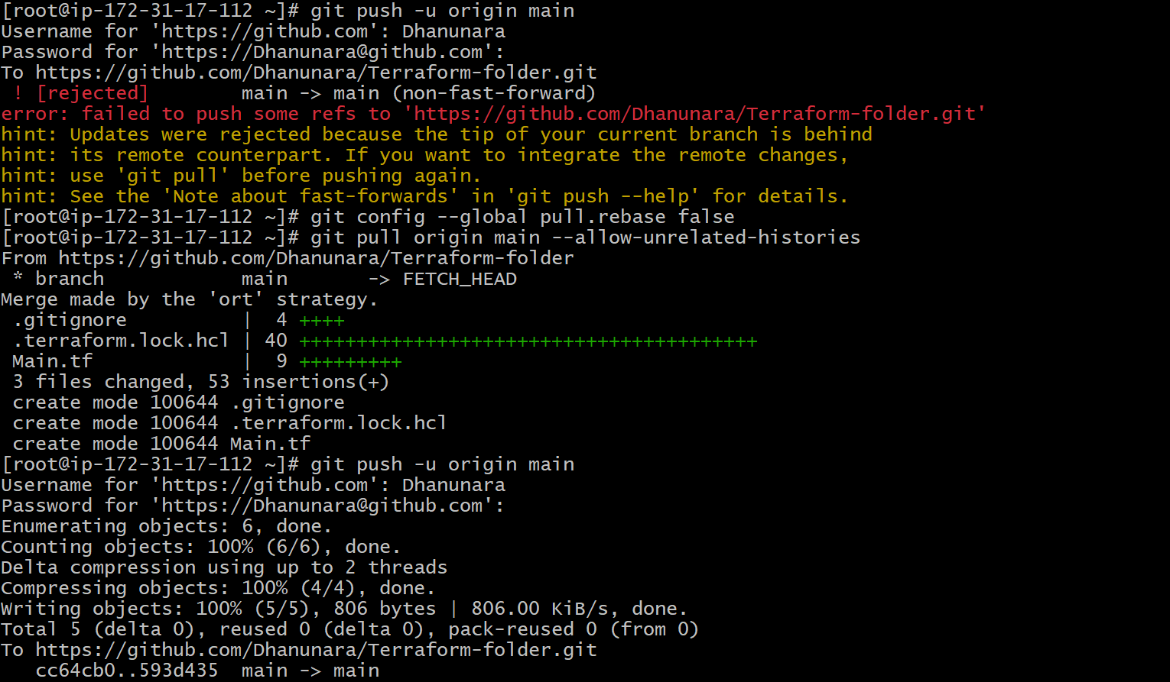
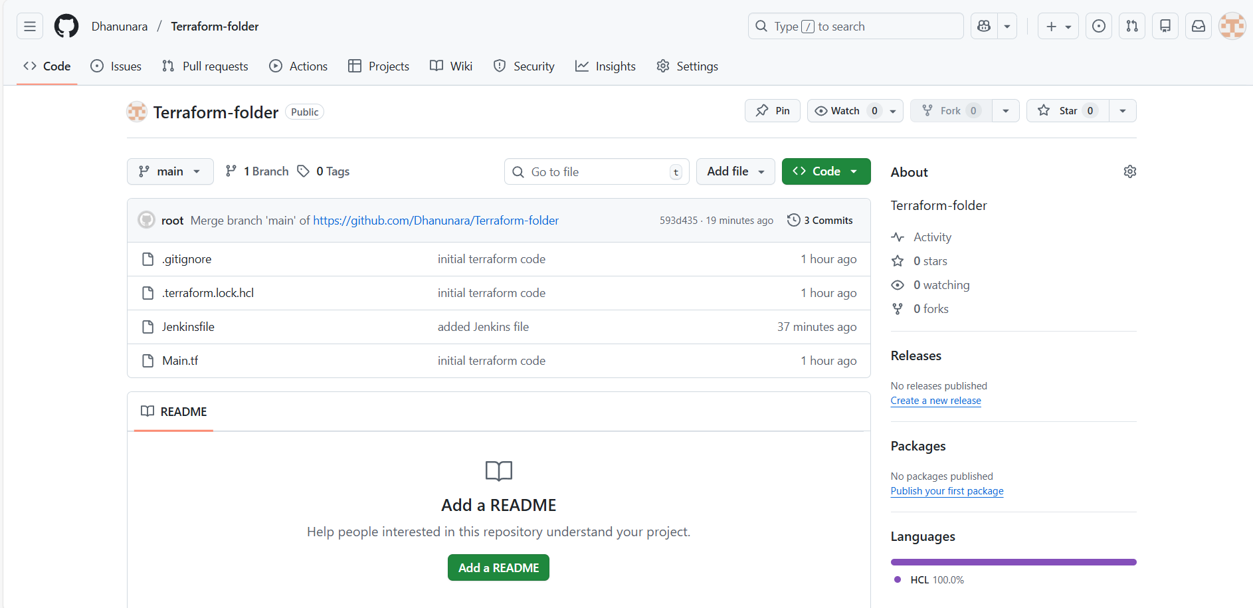
Now create a job in Jenkins GUI

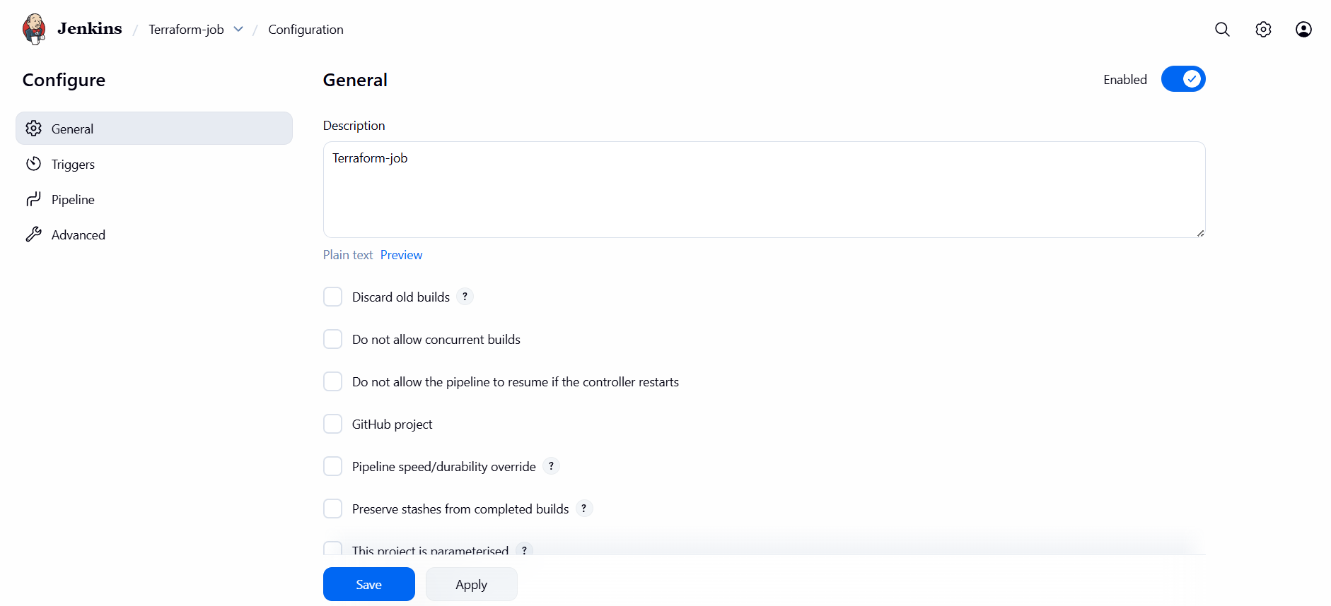

In pipeline select pipeline script from SCM

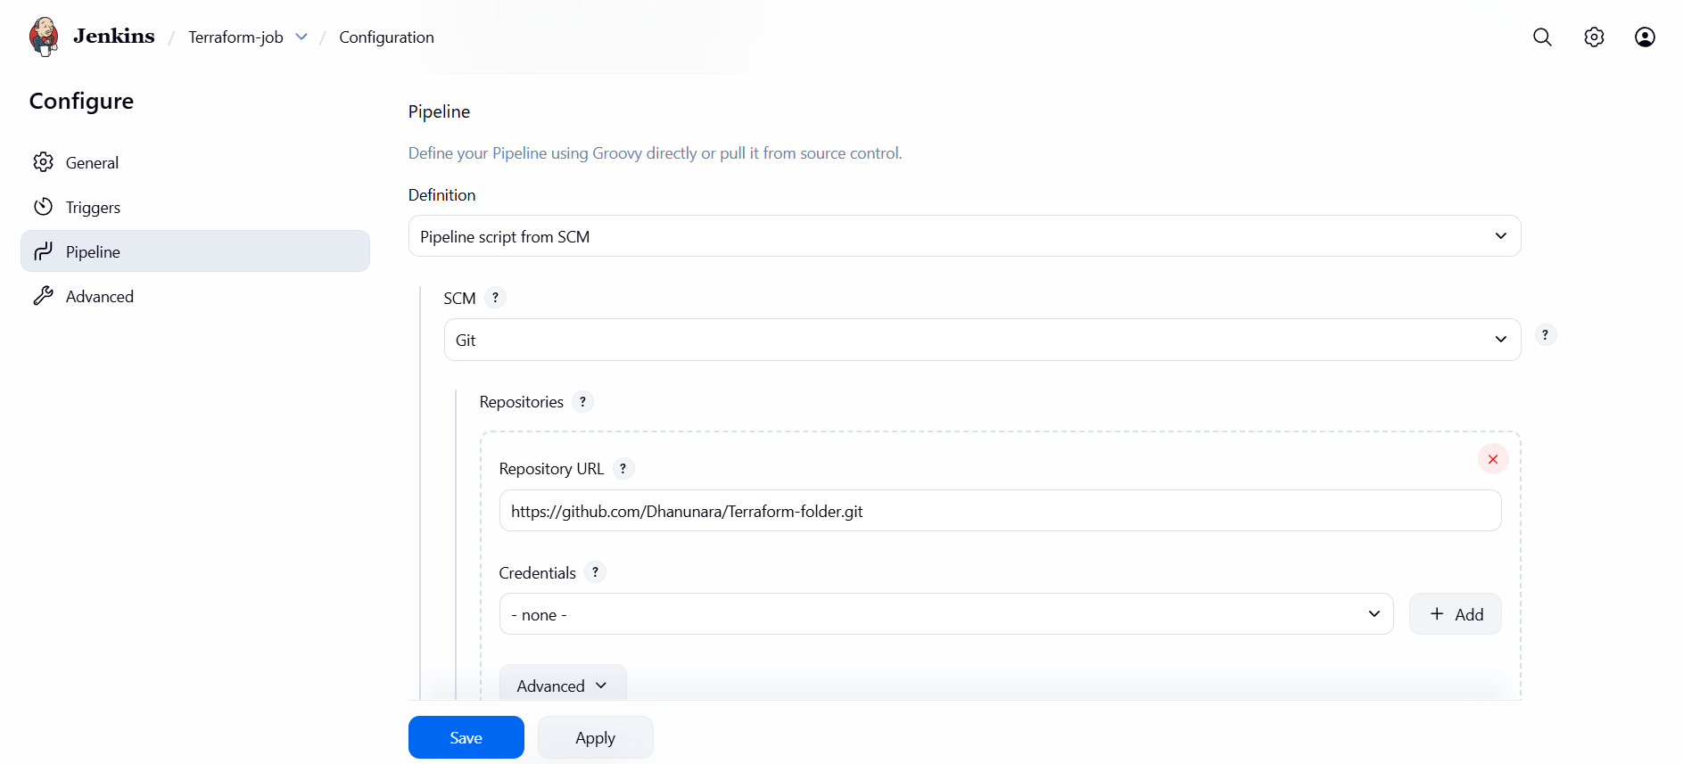
Now click on build
